Post-class activity: Analysing Graphs

Report submission

Analyse the data presented in the graph below by completing an analysis report:

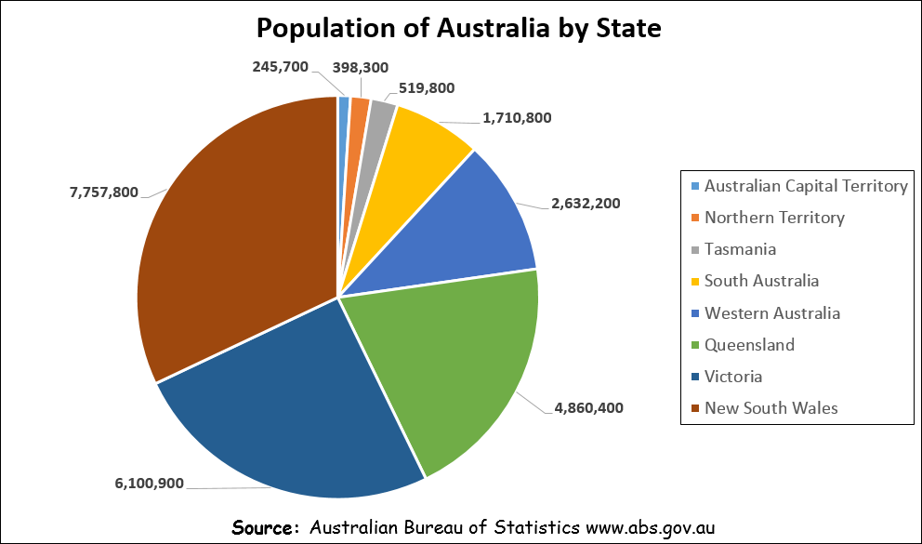

**Graph Analysis report**

1. **Introduction** (write one sentence describing the overall purpose of the graph).

|  |
| --- |
| The graph displays the number of people living in a particular state. |
|  |
|  |

1. **Graph type and purpose** (write two sentences, one sentence identifying the type of graph, the 2nd sentence describing the genetic purpose of that type of graph).

|  |
| --- |
| The graph used to represent the population data is a pie chart. Pie Chart are used to show |
| comparison between data of different categories in proportion to the total data of all categories |
|  |
|  |

1. **Data included** (write one sentence for each data item in the graph).

|  |
| --- |
| The population of each states are represented as slices of the pie chart while different colours |
| are used to represent identify the state of that slice. |
|  |

1. **Main finding/trend** (write one sentence describing the main finding or trend in the graph).

|  |
| --- |
| The main finding in the trend is that New South Wales has the largest population in Australia. |
|  |
|  |

1. **Other findings** (select two or three other things that stand out in the graph – write one sentence for each area.)

|  |
| --- |
| Australian Capital Territory has the smallest population compared to the other states in the |
| Data. Victoria, Queensland, Western Australia and South Australia have more than 1 million |
| people living in them. |

|  |
| --- |
|  |
|  |
|  |

|  |
| --- |
|  |
|  |
|  |

1. **Source of the data** (write one sentence identifying where the data came from).

|  |
| --- |
| The source data came from Australian Bureau of Statistics , their website’s Address is |
| www.abs.gov.au |
|  |

1. **Conclusion** (write one sentence, restating the main findings (in different words than above).

|  |
| --- |
| Overall, the chart shows that the population of New South Wales is the biggest. |
|  |
|  |



The graph displays the number of people living in a particular state.

The graph used to represent the population data is a pie chart. Pie Chart are used to show comparison between data of different categories in proportion to the total data of all categories.

The population of each states are represented as slices of the pie chart while different colours are used to represent identify the state of that slice.

The main finding in the trend is that New South Wales has the largest population in Australia.

Australian Capital Territory has the smallest population compared to the other states in the Data. Victoria, Queensland, Western Australia and South Australia have more than 1 million people living in them.

The source data came from Australian Bureau of Statistics, their website’s Address is www.abs.gov.au

Overall, the chart shows that the population of New South Wales is the biggest.